



To use Drop statement in Library Management System
LAB MANUAL

Disclaimer: The content is curated from online/offline resources and used for educational purpose only
To use Drop statement in Library Management System

Objective:
To use SQL commands like DROP and TRUNCATE to manage database objects. These commands help in permanently removing tables, views, and even entire databases, as well as clearing all data from a table efficiently.
Problem Statement:
In the Library Management System, certain objects are no longer required due to changes in the system's requirements. The tasks are as follows:
Remove the Transactions table entirely.
Drop the entire LibraryDB database.
Delete the ActiveLoans view.
Clear all data from the Books table without deleting the table structure.
Requirements:
- A working MySQL environment.
- Access to the LibraryDB database and its tables, views, and schema.
- Knowledge of SQL DROP and TRUNCATE commands.
Procedure:
Step 1: Start MySQL Server:
Open the command line or terminal.
On Windows: Use MySQL Workbench or run the mysql command.

A) Drop the Transactions Table
The Transactions table is no longer required and needs to be deleted entirely.
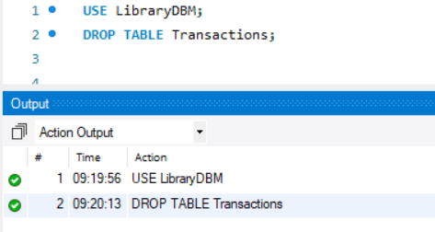

The DROP TABLE command permanently removes the Transactions table and its data from the database.

B) Drop the LibraryDB Database
The LibraryDB database is no longer needed and must be removed entirely.
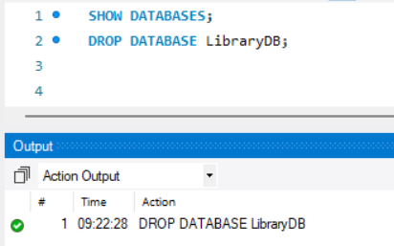

The DROP DATABASE command removes the database and all its objects (tables, views, indexes, etc.) from the server.

C: Drop the ActiveLoans View
The ActiveLoans view is no longer needed and should be removed.

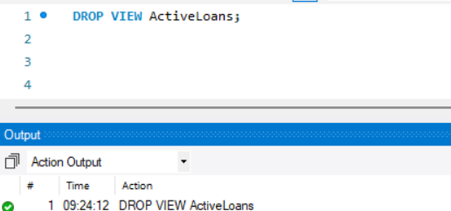

Views are virtual tables; the DROP VIEW command removes the ActiveLoans view definition from the database.
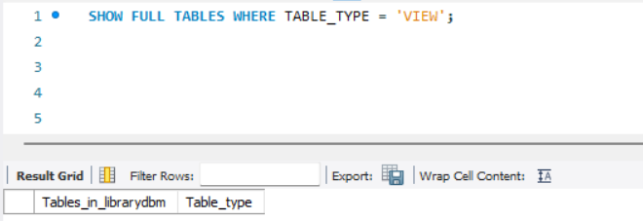

D) Clear All Records from the Books Table
Clear all data from the Books table while retaining its structure.
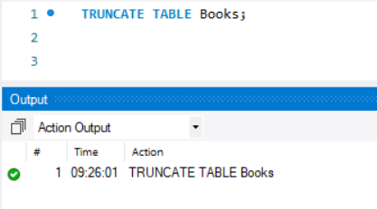

The TRUNCATE command deletes all rows from the Books table. It is faster than DELETE because it does not log individual row deletions and resets the table's auto-increment counter.
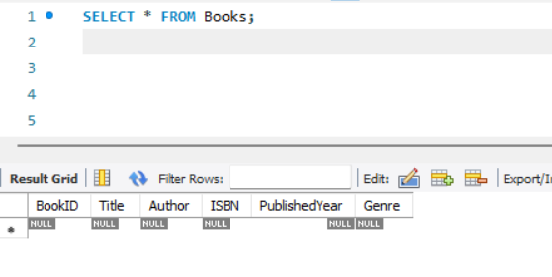

Output:
The queries was successfully executed

